Experiment Number: 6

Problem Statement: Implementation of Classical problem Reader writer using Threads and Mutex.

NAME: **Anish Kamble**  ROLLNO: 55

CLASS: TY(AI-A) BATCH: 3

DATE OF PERFORMANCE: 10/11/22

___________________________________________________________________________

PROGARM:

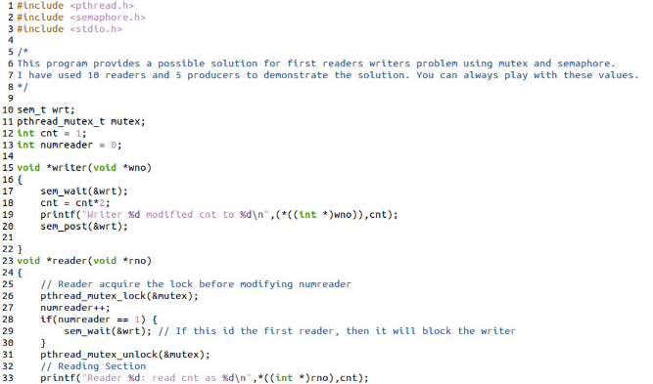

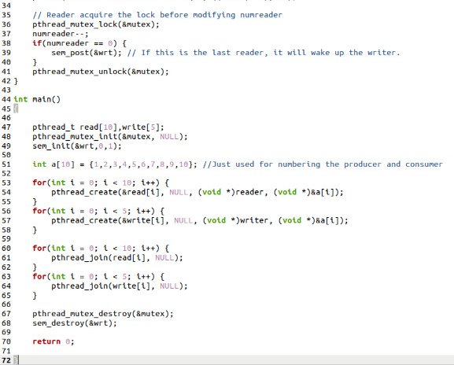

**OUTPUT:**

